Vantage intake and orchestration: concept paper
Stephen Costello · Credit Risk Review · 18 September 2026 · Working draft

Purpose and framing
One intake, two lanes, one orchestrator: files are classified by content shape at upload, documents flow through DEEP, tabular data flows through a profiling path, and a planner routes each question to the cheapest machinery that can answer it with receipts. This paper defines that design for the Vantage use case and shows how the same construction serves cases from a three-column tracking sheet to portfolio-wide scenario screening.
The design answers two live concerns. First, a developer concern: users want to drop CSV and Excel files into the tool for semantic-style questioning, which bypasses the document pipeline, and it was unclear how that would work at all. Second, a positioning concern: Vantage reads as a generic capability, not tailored enough to the variety of individual uses imagined for it. The answer to both is the same. The machinery is deliberately common; the tailoring lives in configuration (question sets, risk posture, output disposition), which is the platform's stated target operating model.
Scope: intake classification, the tabular lane, and question-time orchestration. The document lane (DEEP, retrieval, page-level provenance) is treated as defined and referenced, not re-specified.

Why tabular data breaks the document pipeline
A CSV is not a document; it is a database that has not been loaded yet. The document pipeline works because meaning in prose lives in passages, and chunking preserves it: index and embed, hybrid search, pass relevant chunks to the LLM, return the answer with the source section visible. In a table, meaning lives in the schema and in relationships across cells. Naive row embedding destroys exactly that.
Embedding every row of a large file produces three failures at once:
- Near-identical vectors. Serialized rows of IDs and numbers barely differ, so retrieval returns noise.
- Wrong answer class. Questions like "how many" or "what share of the portfolio" are computed across rows; the answer exists in no row, so no retrieval can find it.
- Cost and latency. Hundreds of thousands of embeddings per file, per upload, for retrieval that does not work.
The reframe: stop asking how to search the file and ask what kind of question the user is posing. Three kinds recur, and each needs different machinery.
Question kind | Example | Right machinery
Computational | "Nominal and % of portfolio exposure with customer concentration above 20%" | LLM writes a query; DuckDB executes it deterministically
Lookup / fuzzy match | "Find the entry about the watch supplier" | Hybrid search over selectively serialized rows
Semantic over free text | "Which comments mention covenant concerns?" | Embed the text-rich columns only; structured columns become filters

The LLM's job shifts from reading the content to writing the program that reads the content. That is why the design does not bog down at scale: model context holds a schema and a question, never the file. DuckDB queries files in place, columnar, tens of millions of rows on a single node, no infrastructure.

Intake: classify by content shape, then profile once
Routing is decided by content shape, not file extension; the extension is only the prior. A Word file or PDF is usually a document, but a PDF can be a pure table extract that belongs in the tabular lane. An Excel workbook can hold a formatted narrative sheet that belongs in the document lane, and a multi-sheet workbook may need per-sheet routing. A lightweight classifier at upload inspects the content and assigns each unit (file or sheet) to a lane. CSV always routes tabular.
Everything expensive happens once, at intake, and is cached against the file:
- Profile. For tabular units: column names, inferred types, cardinality, min/max, null rates, sample values, detected language mix per text column. Output is a schema card of a few hundred tokens regardless of row count. The card is the map the LLM reads; it never reads the data to decide which columns matter.
- Confirm. The system states its interpretation in plain language ("reading counterparty as Cpty_Nm, exposure as EAD_USD") and the analyst ratifies or corrects it. One confirmation per file; every later question inherits the ratified mapping, and corrections persist. This converts the worst failure mode (a silently wrong column mapping under a confident answer) into a visible ten-second checkpoint.
- Construct and embed semantic units. Semantic units are constructed from free-text fields and relevant row context according to the confirmed schema, then embedded at intake so the semantic path is ready at question time. Structured fields remain available as metadata for filtering, aggregation, and provenance; they are never embedded on their own.
Step 3 names a distinct architectural object: the Semantic Unit Specification. The schema card says what the table means; the specification says what representation is submitted to the embedding model, per row or per distinct value, which structured fields ride along as context, and which remain metadata only. A raw comment cell often carries too little on its own: "Counterparty: Acme | Sector: Industrials | Comment: dependent on Chinese rare-earth suppliers" is a retrievable unit where the bare comment is not. The ingestion chain is therefore explicit: physical schema, then schema card (the confirmed semantic schema), then semantic unit specification, then embedding and index.
Three consequences follow. The index is a derived, rebuildable retrieval artifact, never part of the authoritative representation of the uploaded data: change the embedding model, the serialization, or the vector store and the retrieval layer regenerates from confirmed schema plus specification, without reinterpreting the source. The specification is a per-use-case configuration point: a PICH sheet may embed task text plus case ID only, while a portfolio file constructs a richer unit from counterparty, sector, rating, and narrative fields; unit granularity (row-level for genuine free text, distinct-value for de facto enumerations) is a specification property. And it is an auditable artifact, versioned and stamped on the index it built, so the exact embedded representation of any row can be shown. One caution governs its content: context fields are chosen to disambiguate the text, not to restate what metadata filters already handle. Over-stuffed units make every row match queries about its context terms, trading precision away for no recall gain, since structured predicates are already the filters' job.
Column roles are recorded on the card: identifier, measure, categorical dimension, free text. One useful refinement: a text column whose distinct-value count is small relative to row count (a templated task column in a tracking sheet) is flagged as a de facto enumeration, which changes the execution plan from per-row reading to per-value classification.
Multilingual is a platform decision, made once. Text columns in Swiss-booked data will mix German, French, Italian, and English. Three rules:
- One multilingual embedding model for all text. Per-language model routing creates separate vector spaces that cannot see each other, so an English question silently loses the German rows. Language detection informs; it never routes.
- Classify the concept, not the string. Prompts carry intent ("the task asks the credit officer to confirm receipt of new annual financial statements"), not an English keyword, so Bilanz, bilan, and bilancio all match.
- Record the language mix on the schema card and slice evaluation by it. Recall of 97% overall and 82% on Italian is a finding to surface, not to average away.

The two lanes
The document lane is the existing platform path and is not re-specified here: DEEP parses structure-first (parse, build a tree, navigate, map, preserving hierarchy and coordinates), content lands in the document and embedding stores, retrieval filters before it searches, and every answer carries document, page, source text, and visual location. Word routes through the same lane as PDF and is the easier case: headings, lists, and tables are native objects in the file, so the parse tree comes essentially free, where PDF structure must be recovered from layout.
The tabular lane is the new path this paper defines: profile, confirm, selectively embed, then answer questions through the planner described in the next sections. Its provenance artifacts are the executed query and the returned rows rather than a highlighted page, plus the classification table where judgment was involved.
The two lanes are the same doctrine applied to different inputs. Both are structure-first; the difference is that DEEP must recover the structure from layout, while the tabular lane is handed the structure as a schema. Both filter before they search. Both end in an answer with receipts a human can verify without trusting the model's summary.
 | Document lane | Tabular lane
Inputs | PDF, Word, narrative sheets | CSV, Excel sheets, table-extract PDFs
Structure | Recovered by DEEP parsing | Given; captured as a schema card
Unit of meaning | Passage in hierarchy | Cell in schema
Search | Hybrid over chunks | Query over columns + semantic over text columns
Provenance | Document, page, source text, location | Executed query, returned rows, classification table
Expensive step | Parsing at intake | Profiling + selective embedding at intake

The flow: intake lanes and question-time routing
Intake runs once per file (or per sheet, where a workbook mixes shapes) and populates the stores each lane needs.
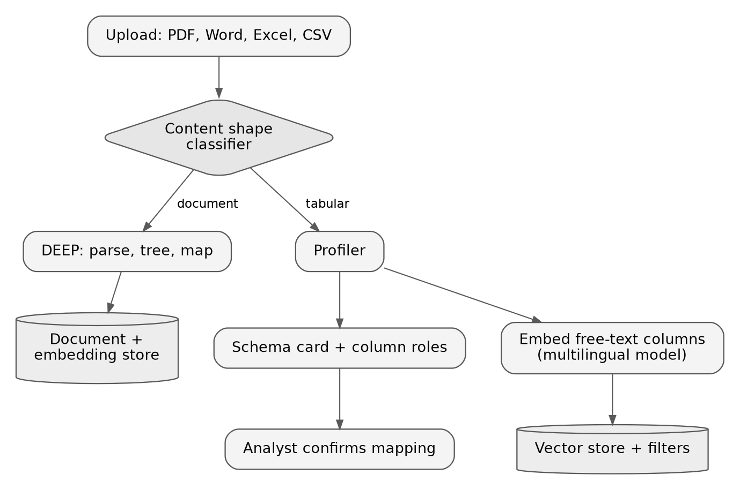
Reading: extension is only a prior; the classifier assigns each unit to a lane by what is inside it, and a workbook can send different sheets down different lanes.
At question time the planner reads the cached schema card and dispatches only the machinery the question needs. Most questions take the cheap path.
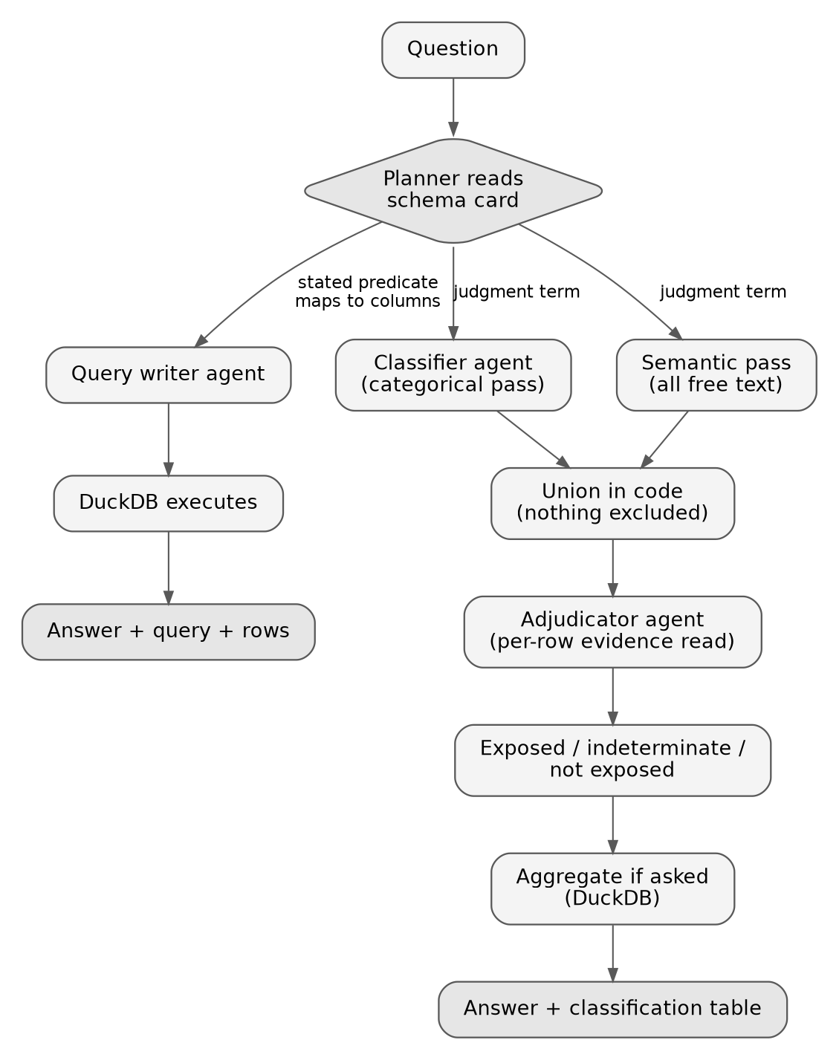
Reading: the two judgment passes run in parallel and independently; the categorical pass prioritizes but never excludes, so the only route out of scope runs through the adjudicator with a text-grounded reason. Questions against documents route through the document lane's existing retrieval and are not redrawn here.
Edits to the classification table re-run only the deterministic bottom of the flow; the expensive agent steps above do not repeat.

Question-time orchestration: agents where judgment lives, code everywhere else
The orchestrator is a router, not a pipeline. Its first act on any question is a plan: which steps does this question actually need? A stated predicate that maps to columns ("concentration above 20%", when a concentration column exists) goes straight to query writing. A judgment term ("impacted by rare-earth tariffs") triggers the two-pass screening. A list request may need no SQL at all; the adjudicated set is the answer. The planner also handles the derivable case: when a concept is not a column but can be computed from columns, it derives it in SQL; when it lives only in narrative fields, it routes the question semantically. The rule the planner encodes: filters implement what the user stated; they never implement what the model judged.
Exactly four LLM judgment points exist, each with a visible artifact:
Agent | Judgment | Artifact
Planner | Which machinery the question needs | The plan, shown with the answer
Classifier | Categorical pass over distinct values, concept-level | Tiered value classification
Adjudicator | Evidence-backed call per candidate row | Reasoned call per name, editable
Query writer | Translate intent to SQL | The query, executed deterministically

Everything between them is plain code: profiling, embedding, search execution, the union, DuckDB execution, aggregation, packaging. Deterministic steps are never wrapped in agents. This keeps guaranteed behaviors guaranteed, and it bounds the governance surface to four judgment points connected by auditable plumbing.
Two efficiency rules do most of the scaling work:
- Classify vocabularies, not rows. A 150k-row file has perhaps 200 distinct sector values, and a templated task column behaves the same way. The classifier reads distinct values once; a deterministic join tags every row. The per-row adjudication read runs only over the union of candidates, typically thousands of rows, never the file.
- SQL is an audit artifact, not an authoring surface. Analysts write plain English. The generated query ships with every computed answer behind a show-your-work disclosure, like a formula bar: its existence makes the number trustworthy, and nobody is required to read it. The interpretation layer that does face the analyst is plain language: grain, columns, and filters restated as a sentence.
One failure mode deserves explicit treatment: a syntactically valid query that is semantically wrong (wrong join, wrong filter) fails silently. Showing the query is therefore the verification mechanism, not just provenance, and the UI should treat it as such. The schema card also arms the planner against the common variant: a counterparty column with 12,000 distinct values against 150,000 rows says the file is facility-grain, so "how many counterparties" must count distinct.

Scenario screening: two independent paths, union, adjudication
Judgment questions ("which borrowers are impacted by a new tariff on rare earths?") cannot be answered by a filter, because the exposure concept exists in no column. The screening design rests on one recall principle: categoricals prioritize, they never exclude. A filter-then-refine sequence has a silent hole: an industrial bank coded "Financials", or a hedge fund specializing in data centers, is dropped by the sector filter and its free text, which states the concentration plainly, is never read. A recall failure is invisible; the answer comes back internally consistent and nobody knows what was missed.
The construction:
- Path A, categorical. The classifier reads the distinct values of the categorical dimensions against the scenario and tiers them: exposed, dependent, not exposed, and indeterminate-from-code. Every intermediary and pass-through category (banks, funds, asset managers, holding companies, "diversified") lands in the indeterminate tier by rule. A sector code on an intermediary describes its legal form, not its economic exposure; this is the look-through problem, and the classifier is prompted to know it.
- Path B, semantic. Search over the embedded free text of the whole file, not just Path A's candidates. Path B does not trust Path A's exclusions; the independence is the recall guarantee. The two paths run in parallel.
- Union in code, then adjudication. The candidate set is everything either path surfaced. The adjudicator reads only this union and makes an evidence-backed call per name, with a one-line reason drawn from the row's own text. Precision errors from Path B are caught here, and any that survive are visible in the output.
The output has three tiers, and the third is load-bearing:
- Exposed: drives the deterministic aggregate (counts, sums, share of book).
- Not exposed: excluded only through the adjudicator, with a reason; never by a code alone.
- Indeterminate, insufficient look-through information: reported with its own count and exposure total beside the answer. "247 counterparties exposed, CHF 4.2bn (6.3% of book); a further 31 financial intermediaries, CHF 1.1bn, could not be assessed from available data." The tool quantifies the file's silence instead of guessing over it, which is the tabular twin of the platform rule that an untraceable answer does not enter a deliverable. It is also the work queue: those 31 names are the list to fetch look-through data for.
The classification table is editable, and edits re-run only the deterministic aggregate. The analyst adjusting the exposed set (do semiconductor equipment makers count? distributors?) turns a one-shot answer into a scenario tool, at query cost rather than LLM cost. Doubt is deliberately pushed toward false positives, because false positives are displayed and correctable while false negatives are silent.

Worked cases: the same machinery, scaled down and up
PICH tracking sheet (scales down). A pending-items extract with three effective fields: case ID, due date, and a CO task column whose text may be German, French, Italian, or English. The question: which items ask the credit officer to verify that a new balance sheet was submitted, so that items already satisfied can be closed without manual work. The schema card is nearly trivial; the planner sees no categorical vocabulary worth a Path A pass and no aggregate, so the whole question routes through the semantic path plus adjudication, and the classification table is the deliverable. The templated task column is a de facto enumeration, so the classifier reads a few hundred distinct strings, not 80k rows. Same four agents, three of them idle or trivial; nothing special-cased. Two boundaries: the actioned outcome is deletion of a control step, so the flow proposes and a human ratifies (see risk posture below), and checking the internal rating database for whether a balance sheet already exists is a lookup in another system, out of Vantage's scope until a governed connector exists.
Buried concentration (planner branching). "Nominal and % of portfolio exposure with customer concentration above 20%." If a concentration column exists, this is pure filter-and-aggregate: query writer, DuckDB, done, no semantic machinery. If concentration is derivable from customer revenue columns, the planner derives it in SQL. If it lives only in narrative fields, the planner sees that from the schema card and routes the question semantically. Three executions of one question, chosen from the map, never from the data.
Semiconductor supply shock (scales up). "How many counterparties would be exposed to a critical semiconductor supply shock, and what share of the portfolio?" The full construction: two parallel passes, union, adjudication, three-tier output, deterministic aggregate with distinct-counting at the right grain, and the quantified-indeterminate line beside the answer.
ERM read-across (the pattern one level up). The event-identification case ("which clients are exposed to this event?") is the same planner consulting a catalog of schema cards and document indexes instead of one file's card: what information exists already, what is in the uploaded PDFs, which candidate datasets and text fields to look over. The schema card generalizes into the platform's answer to "what do we know and where," which is also the seed of the knowledge-graph story.

Risk posture and governance
The risk asymmetry differs by use case, and the architecture absorbs it through configuration, not code. In scenario screening the dangerous error is the false negative (silent missed exposure), so doubt is pushed toward inclusion and the amber tier. In the PICH case the actioned outcome is deletion of a control step, so a false positive is the dangerous error, and the amber tier's default disposition flips to human review before any action. The machinery is common; the risk posture per use case (tier thresholds, default dispositions, whether output is a proposal or an answer) lives in use-case configuration. This is the concrete answer to "too generic": tailoring by configuration is the platform's target operating model, applied.
Provenance artifacts by path, all shown or one click away:
- Computed answers: the executed query and the returned rows, deterministic and re-runnable.
- Judgment answers: the plan, the tiered value classification, and the per-name reasoned call, editable.
- Both: the confirmed schema mapping and the version of the semantic unit specification the retrieval index was built from.
Evaluation is part of the design, not an afterthought: recall and precision measured per language and per question kind, with the per-language slice reported, given the DE/FR/IT/EN mix in scope. Schema-mapping confidence is measured too; unmappable question terms, ambiguous exposure columns, and mixed-currency measures (a currency column with several values means a sum needs conversion or a caveat) escalate to the analyst rather than resolving silently.
Boundaries stated up front: Vantage's job in any workflow ends at the classified, evidenced candidate list or the computed answer. Lookups in other systems are exports the business joins, or governed connectors later, with the entitlement and data-access questions that implies. Arbitrary uploaded tabular data also has no ingestion identity and permissions story today the way documents do; "what data just entered the tenant" is a question the retrieval layer's model will eventually need to answer for tables, and it is flagged here so the deferral is deliberate.

Decisions and open questions
- Schema card: decided (2026-09-18). It is a first-class platform object, cached and reused; standard profiling outputs are captured once and reused, saving compute and latency. Versioning and attributed correction history remain to be specified.
- Content-shape classifier: decided (2026-09-18). A central service-layer capability; applications invoke it per use-case configuration and it is served through the UI. Runtime sequence: user uploads, the file is saved (profiling can start asynchronously here), the user enters questions or configuration, structure is captured and confirmed to the user, then the question routes down its path.
- Embedding model: confirm with the platform team rather than assume. Likely multilingual given the bank's language mix, but the extraction-heavy use cases to date barely exercise embeddings, so request the per-language retrieval evaluation (DE/FR/IT/EN) for semantic search over short free-text fields.
- Ingestion identity and permissions: uploaded tabular files follow the same permissions requirements and shape as documents (decided 2026-09-18); one intake identity model for all file types, with the entitlement gateway enforcing at query time. Open: whether these attributes, and the tabular artifacts they attach to (raw file, schema card, semantic unit specification version), are retained in the central storage layer alongside raw and parsed documents, or live only application-side. Central retention is what lets enforcement work uniformly and what extends process-once reuse to tables; the question for the platform team is whether the store's raw-plus-parsed shape accommodates a tabular unit as a first-class stored object or is document-only by design.
- PICH rating-database check: earliest acceptable integration shape (manual export and join vs. governed connector) and under whose entitlement model. Confirmed as a follow-up.
- Risk-posture configuration fields: deferred. Candidate for a 2H27 release; viability still being assessed. Not required for the initial design, which carries the concept only.

